

Dear All,
We are saying a fond goodbye to Jordan, who is moving into a small animal role and to Stijn who is heading off to travel in Australia.

We wish them both the very best in their new adventures, and we would like to thank them for all their hard work over the last few years. We have started looking to interview for a new colleague but in the meantime Trevor Dickson, who many of you may remember of old, has agreed to cover for us.

Now that spring is here, many pets begin to show signs of seasonal allergies. Just like people, animals can react to pollen, grasses, moulds, and even everyday substances in the home. Understanding the signs and knowing when to seek help can make a huge difference to your pet’s comfort and wellbeing.

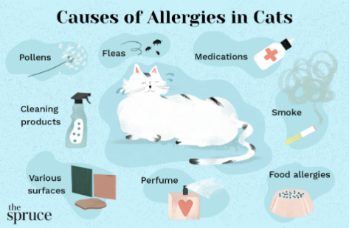

How You Can Help at Home
Small changes can make a big difference:
- Wash bedding regularly
- Vacuum frequently to reduce dust and pollen
- Rinse or wipe paws after outdoor walks
- Keep up with year-round parasite prevention
- Avoid using strongly scented cleaning products or sprays
These steps help reduce allergen exposure and support your pet’s comfort.

🐶🐱 When to Contact Your Vet
If your pet is itching, licking, or showing any signs of skin irritation, it’s best to get them checked. Early treatment prevents discomfort and reduces the risk of secondary infections.

Easter Bunny Bites – Pet-Safe Dog Treats
These soft, chewy treats are ideal for dogs and can be shaped into little Easter eggs or bunny faces for a festive touch.
Ingredients
- 1 cup oat flour (or blitz rolled oats in a blender)
- ½ cup mashed banana or unsweetened applesauce
- ¼ cup peanut butter (ensure xylitol-free)
- 1–2 tbsp water if needed
- Optional: 1–2 tbsp finely grated carrot for colour and sweetness
Instructions
- Preheat your oven to 180°C (350°F).
- Mix the oat flour, banana/applesauce, and peanut butter in a bowl.
- Add grated carrot if using.
- If the dough feels dry, add a splash of water until it comes together.
- Roll into small balls and gently shape into “Easter eggs” or flatten with a cookie cutter.
- Place on a lined baking tray and bake for 10–12 minutes until firm but not hard.
- Cool completely before serving.
- Freeze for up to 2 months.



Easter Pet Photo Feature
Show off your pet’s springtime sparkle
Spring is here, and we’d love to celebrate it with the stars of our practice—your pets. Whether it’s a dog enjoying a sunny walk, a cat posing among the daffodils, or a rabbit exploring the garden, we want to see your favourite spring-themed photos.
Send your pictures to admin@moorgatevets.co.uk throughout April, and we’ll feature a selection on our Facebook page. Cute, funny, muddy, or majestic—every pet is welcome.

Practice Facilities
Appointment System
Parking
24 Hour Emergency Service
Modern Surgical Facilities
Nurse Clinics
In-House Laboratory
Digital X Ray Machine
Endoscopy
Pet Care Plans

BOVEY TRACEY SURGERY
Mill House, Station Road,
Bovey Tracey, Newton Abbot, TQ13 9AL
TELEPHONE – 01626 833023
EMAIL: admin@moorgatevets.co.uk

MORETONHAMPSTEAD
SURGERY
Unit 4,
Gales Sawmills,
Moretonhampstead,
Newton Abbot, TQ13 8LG
TELEPHONE – 01647 440441
EMAIL: moorgatetb@moorgatevets.co.uk

CHRISTOW SURGERY
4b Gidley’s Meadow, Christow,
Exeter, EX6 7QB
For appointments/repeat prescriptions etc.
TELEPHONE – 01626 833023

FOR OUT OF HOUR EMERGENCIES PLEASE TELEPHONE: 01647 440441

www.moorgatevets.co.uk

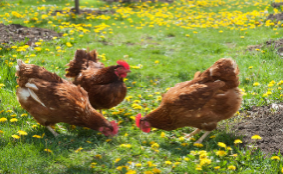



Springtime Cat Grooming Tips
As days get longer, cats naturally shed their dense winter undercoat. A little extra grooming now can make a huge difference in comfort—for both of you.
Different coats benefit from different brushes:
Short-haired cats: Rubber curry brushes or grooming gloves help lift loose fur gently.
Medium/long-haired cats: Slicker brushes or wide-tooth combs reach deeper into the coat.
Heavy shedders: Undercoat rakes or de-shedding tools (like a Furminator-style brush) remove loose undercoat efficiently.
Aim for 3–5 short sessions per week. For long-haired breeds, daily brushing during peak shedding can prevent mats. Always brush with the grain of the fur first. For long-haired cats, you can gently lift sections and brush underneath to prevent tangles. Use a damp cloth or a grooming glove after brushing, this picks up loose fur the brush missed and reduces the amount that ends up on furniture.

Easter Spot the Difference
There are eight differences to be found





